
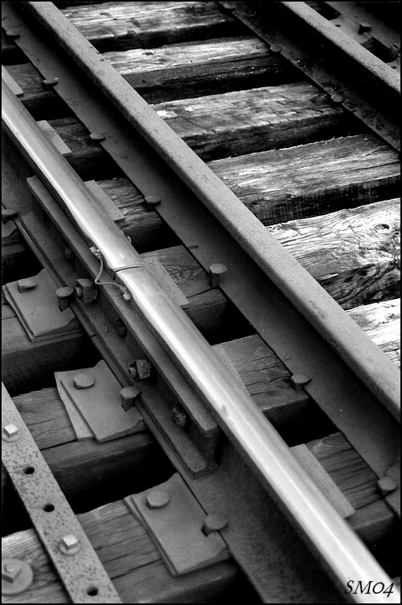
#13
Ribbon of Broken Dreams
John Spearn

From the album ‘Northern Sightlines’

Reidmore Books

Vocabulary

- one-way fare -
- wire your wages -
- tattered -
- chaps -

Do You Know It?

CAN YOU FIND ON A MAP:

- British Columbia - China - Canton

Did You Catch It?

- Where did Chang come from?

- Where was he going?

- What did Van Horne want more of?

- What did the foreman cry?

- What did the foreman want to do about the “rock”?

- What were the men expected to “volunteer” for?

- What would be their reward according to the lyrics?

- What promise was made to them if they did not survive?

- What was it that killed so many of the workers?

- Where are the dead men buried?

- How many men died according to the songwriter?

58

Do You Get It?
- What is meant by “British Columbia’s future design”?

- What was it that killed and injured so many of the workers?

- What promise was made to them if they didn’t survive?

- Who was Van Horne?

- Where do you think Hell’s Gate got its name?

- What eventually occurred as a result of British Columbia agreeing to become a province of Canada?

- What was the “dream” of Sir John A. MacDonald?

- Much of this song deals with the life of the railroad worker.

  - Why were the labourers treated with such disregard?
  - Does such treatment occur in today’s world?
  - Discuss what rights the workers had or lacked

Activities and Extensions!

- In what year was the Trans-Canadian railroad completed?
- Who drove the ceremonial “last spike”? At what location?
- What year did the railroad come to your city or town?

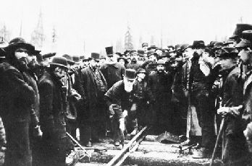

Ottertail Bridge
Wooden trestle bridge, CPR
(courtesy Vancouver Public Library/31075).
www.thecanadianencyclopedia.com

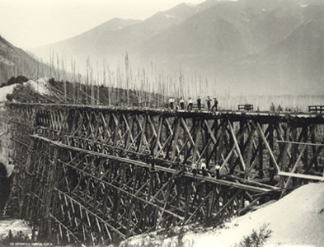

The Last Spike!
The symbolic last spike in the building of the CPR was driven by Donald Smith on Nov 7, 1885 (Courtesy National Archives of Canada/photo by Ross Best & Co/C-3693).
www.thecanadianencyclopedia.com



Teacher’s Guide

BACKGROUND INFORMATION

When British Columbia joined Canada in 1871, a promise was made that a railway would be built between the new province and Ontario within ten years. Prime Minister John A. Macdonald championed the railway. He believed that it was crucial to the future of Canada. Without it, he believed Canada would lose its claim on the western territories to the United States, which was expanding rapidly westward.

During this time thousands of migrant Chinese workers were brought in to help. Through the harrowing Rocky Mountain passes, it is estimated that one Chinese worker was killed for every mile of track.

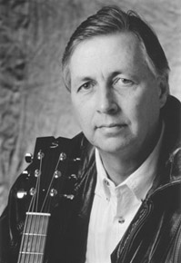

ARTIST INFO

John Spearn You’ll instantly catch these deep influences threaded throughout John’s fine vocals, lyrics, and rootsy, guitar-mastered songwriting works. His grant-supported Canada Songs and Northern Sightlines CDs have taken him from coast to coast as a major festival performer, workshop host, historical curriculum writer, and multiple award nominee. This is pure Canadiana: forgotten but deserving heroes, the humility in our international image, and stories that need to be told. www.canadasongs.com

ANSWER KEY
“Did You Catch It”

- Canton, China
- To work in the land of the free (The Golden Sun)
- Poor Chinese chaps (labourers)
- Onward!
- Blast through it
- Go into the caverns and plant dangerous explosives (nitro)
- 10 dollars (speculative)
- Money would be sent for their families in China
- Explosions, unsafe working conditions, falling off of cliffs and bridge decks, disease, slave-like treatment
- Graveyards of the new railroad towns, or along the tracks in the nearby trees.
- 600 – 3 = 597 (speculative)

ADDITIONAL RESOURCES

- View the Heritage Minute - #21 – “Nitro”, put out by Historica. Have the students compare the portrayal of the Chinese workers in this video to “Chang” in the John Spearn song. What similarities and differences can they indentify?

